**WEEk 3&4**

**CN LAB**

# Y. Shamil Ahamed

# 1BM21CS248.

## **Left Router:**

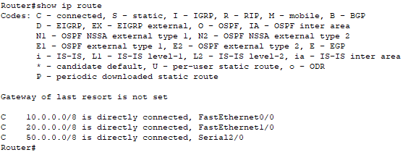

## **Middle Router :**

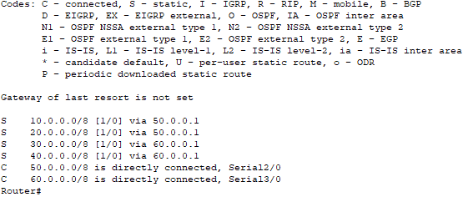

## **Right Router:**

